Project Design Phase
Solution Architecture

Date | 22 September 2026
Team ID | SWTID-2026-3942
Project Name | AI StudyBuddy
Maximum Marks | 4 Marks
Solution Architecture Overview:
The solution architecture of AI StudyBuddy defines a secure, multi-tier RESTful Web API structure connecting authenticated clients, MongoDB database storage, and external Google Gemini AI engine services.
Solution Architecture Diagram (Flow 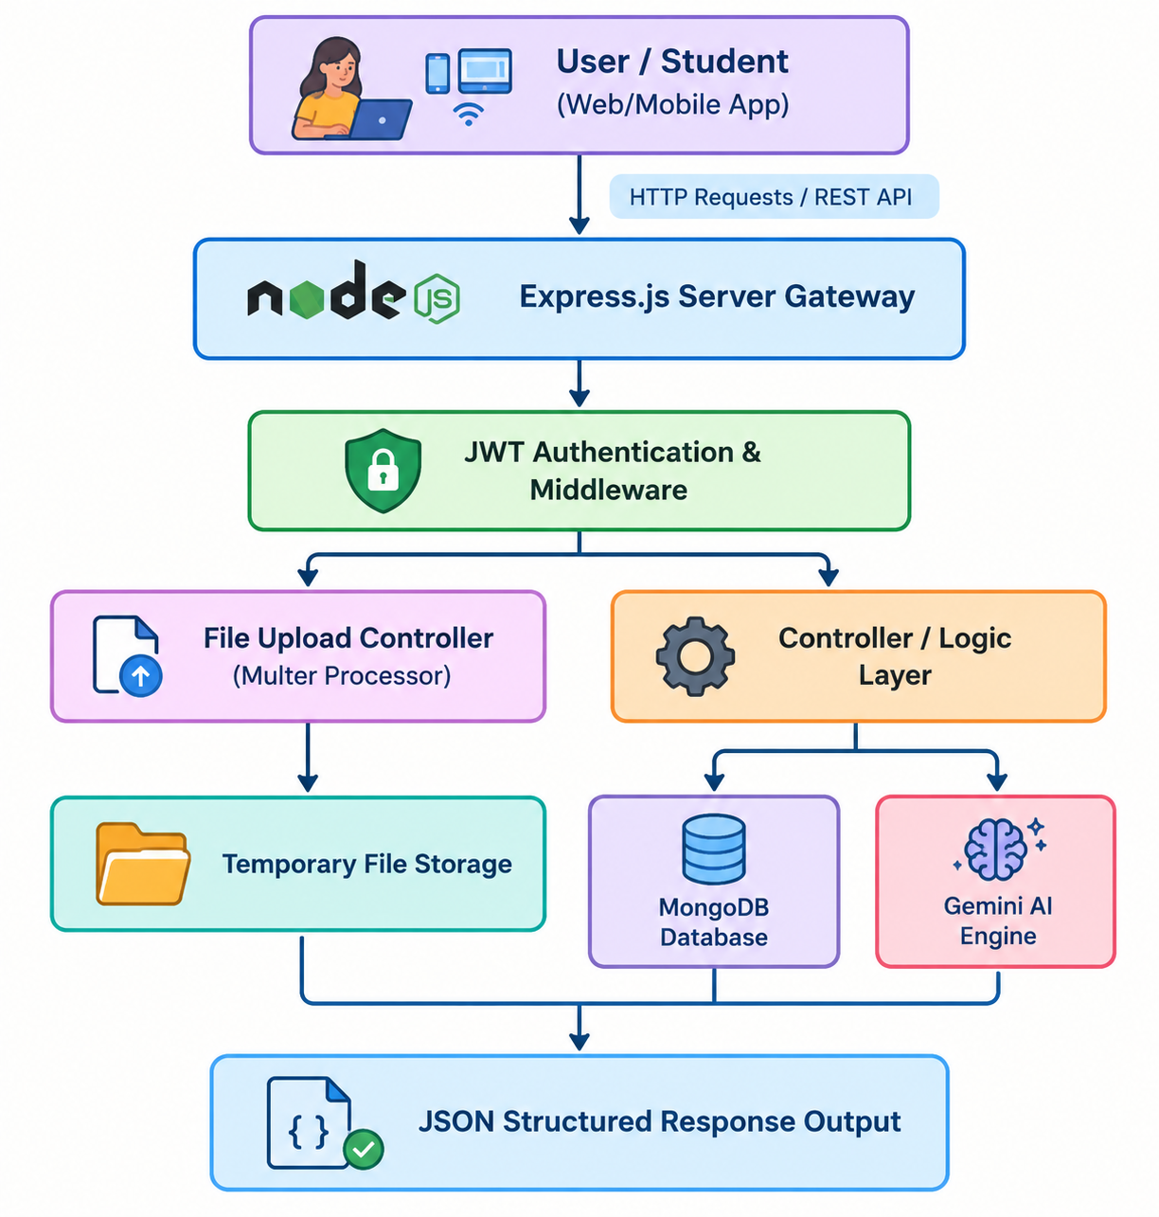

Representation):
Layer / Process Architecture Table:
Layer / Process | Flow | Component / Technology
Client / API Consumer | → | Frontend Web/Mobile Application (React / Cross-platform)
REST API Gateway | → | Express.js Web Server (Handles Endpoints & Routing)
Security & Middleware | → | JWT (JSON Web Token) Authentication & Middleware
Application Logic | → | Node.js Express Controllers
Database Storage Layer | ↔ | MongoDB Atlas & Mongoose ORM (User Profiles, Saved Notes, History)
AI Processing Layer | → | Google Gemini 2.5 Flash AI API (Summaries, Quizzes, Flashcards)
File Processing Layer | → | Multer Middleware (Handles Document & PDF Uploads)
Output Layer | → | Standardized JSON API Response

